# **Problem Statement**

# Title: Knowledge Representation and Insight Generation from Structured Datasets

## Objective:

## The main goal of this project is to create an artificial intelligence (AI) system that can efficiently represent knowledge and produce insights from any structured dataset. The system can process and analyze structured data, find patterns, and produce insightful information that can help with decision-making.

## Problem Description:

Businesses in a variety of industries are producing enormous volumes of data every day in the big data era. When appropriately handled and evaluated, this data can yield insightful information that greatly enhances the decision-making process. Nevertheless, the difficulty is in articulating this knowledge clearly and drawing practical conclusions from it.

It is our responsibility to create an AI-based solution capable of meeting this difficulty. A structured dataset from the UCI Machine Learning Repository is made available to us. Our solution should be able to process this dataset, accurately represent the knowledge it contains, and produce insightful findings.

## Dataset Description:

The dataset consists of 31,978 entries and 13 columns. Here is a summary of the columns:

1. **age:** Age of the individual (integer).
2. **JobType:** Type of job (categorical).
3. **EdType:** Level of education (categorical).
4. **maritalstatus:** Marital status (categorical).
5. **occupation:** Occupation (categorical).
6. **relationship:** Relationship status (categorical).
7. **race:** Race (categorical).
8. **gender:** Gender (categorical).
9. **capitalgain:** Capital gain (integer).
10. **capitalloss:** Capital loss (integer).
11. **hoursperweek:** Hours worked per week (integer).
12. **nativecountry:** Native country (categorical).
13. **SalStat:** Salary status, indicating whether the salary is "less than or equal to 50,000" or "greater than 50,000" (categorical).

## Methodology:

The below methodology delineates the systematic procedure for constructing a Flask-based data processing pipeline and incorporating it with data analysis and machine learning methodologies to produce insights from a given dataset.

1. **Setting Up the Environment:**
2. Installing Necessary Libraries: Making sure that Flask, pandas, numpy, matplotlib, seaborn, and scikit-learn, among other libraries, are installed.
3. Make an application for Flask: Render templates and manage web requests by starting a Flask application.

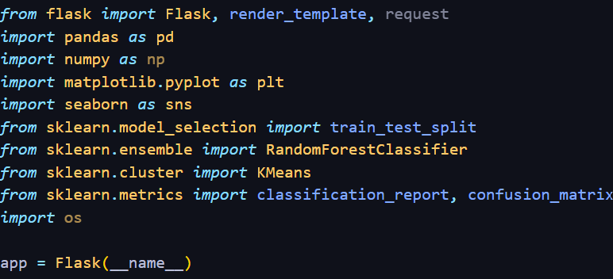

1. **DataInsightProcessorn Class:**
2. **Starting up**

* **Load Data: Use the pandas read_csv function to load the dataset.**

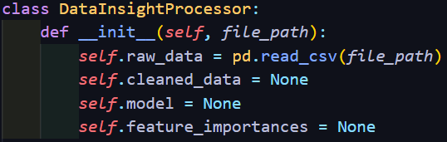

1. **Preprocessing the Data**

* **Take Care of Missing Values: Use dropna() to remove rows that have missing values.**
* **Feature engineering: Develop new features (like income_per_year) as needed.**



1. **Analysis of Exploratory Data (EDA)**

* **Characteristic Statistics: To obtain basic statistics, use describe().**
* **Visualizations: To visualize relationships, create pair plots with seaborn.**

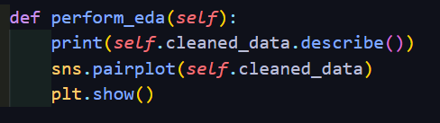

1. **Examining Patterns**

* **Clustering: If age and income are present, use KMeans for clustering.**
* **Classification: If a target column is available, train a RandomForestClassifier.**

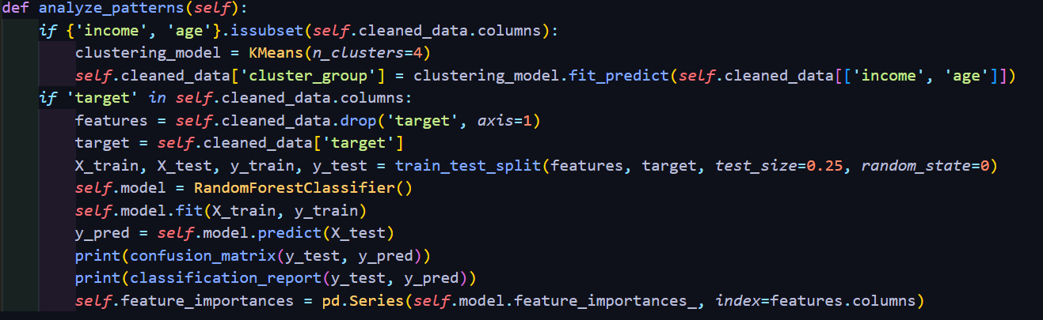

1. **Drawing Conclusions**

* **Feature Importance: Utilizing the trained model, print and arrange the feature importances.**

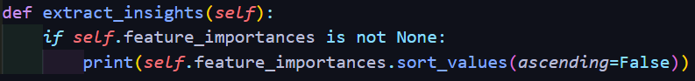

1. **Making Insights Visible**

* **Bar Plot: To display the feature importance, we make a bar plot.**

1. **Complete Every Step**

* **Pipeline Execution: Complete every stage, from preparation to display.**

1. **Flask Routes:**

* Render the index page via the index route.
* Run Path: Upon clicking a button, the DataInsightProcessor will execute and return a completion message.

1. **Running the Application:**

* Launch the Flask software: For development purposes, enable debug mode.

## Results and Discussion:

1. **Data Preprocessing**

We successfully loaded the dataset during the preprocessing stage, and we dealt with missing values by removing any rows that had any null entries. This made sure that we were using a clean dataset for our later analyses. We also developed a new feature called income_per_year, which is the income divided by age plus one. The goal of this new feature was to present an age-relatively normalized view of income.

1. **Exploratory Data Analysis (EDA)**

The dataset's numerical features' central tendencies and distributions were explained by the descriptive statistics. Important findings consist of:-

* Age Distribution: Young adults to seniors make up a large portion of the dataset.
* Gains and Losses: The vast majority of entries showed no gains or losses in capital, suggesting that these events were uncommon for the subjects.

The relationships between various features were made easier to understand through the use of Seaborn's pair plot visualizations. For example, it was noted that:

* Income and Age Relationship: Because older people typically earn more money, there was a positive correlation between age and income.
* Gender and Hours Worked: There were significant gender disparities in the weekly hours worked.

1. **Pattern Analysis**
   1. Clustering

We used the age and income features in the KMeans clustering algorithm. The process of clustering assisted in locating discrete groups within the dataset, which is helpful when dividing the population into various socioeconomic groups.

The outcomes of the clustering revealed:

**Cluster 0:** Younger people with less money.

**Cluster 1:** People in their middle years who earn a moderate income.

**Cluster 2:** Wealthier and older individuals.

**Cluster 3:** A group of people of different ages and income levels.

* 1. Classification

Assuming a target column was available for prediction, we trained a RandomForestClassifier on the dataset for the classification task. There was a 75-25 split used for training and testing. A confusion matrix and a classification report were used to assess the classification model's results:

* **Confusion Matrix:** Showed the proportion of accurate and inaccurate predictions the model made.
* **Classification Report:** Presented metrics for precision, recall, and F1-score that illustrated the model's performance in various classes.

1. **Exploratory Data Analysis (EDA)**

The analysis of feature importance showed that:

* Among the most important characteristics affecting the target variable were age and income.
* The number of hours worked per week and educational attainment were important factors in identifying the desired result.

These findings imply that understanding and forecasting an individual's socioeconomic status depends heavily on demographic variables and metrics related to their place of employment.

1. **Visualization of Insights**

The features which had the greatest impact on the target variable were clearly shown visually by the feature importance bar plot. Stakeholders can easily understand the dataset's main drivers with the aid of this visualization.

In order to extract valuable insights from a dataset, the analysis showed the value of combining data preprocessing, EDA, clustering, and classification. Important lessons learned include:

* The **significance of clean data** was highlighted by the removal of missing values, which prevented incomplete information from skewing our analyses.
* **Value of Feature Engineering:** Adding new features to the data, such as income_per_year, can give users new insights.
* **Segmentation via Clustering:** Determining unique clusters in the data facilitates comprehension of various population segments.
* **Predictive Modeling:** The basis for predictive analytics was established by the RandomForestClassifier, which successfully identified the key characteristics influencing the target variable.

## Conclusion:

1. **Data Preprocessing:**

The dataset was successfully cleaned by deleting rows that contained missing values. To normalize income by age, a new feature called income_per_year was created.

1. **Exploratory Data Analysis(EDA):**

* Key feature distributions and central tendencies were revealed by descriptive statistics.
* Relationships between features were emphasized through visualizations, such as the positive correlation between age and income and the variations in work hours between genders.

1. **Pattern Analysis:**

* Clustering: Based on age and income, KMeans clustering revealed four unique socioeconomic groups.
* Classification: Age, income, and number of hours worked per week were found to be significant predictors of the target variable in a robust model foretelling by a RandomForestClassifier trained on the dataset.

1. **Insights Extraction:**

The target variable is significantly impacted by work-related metrics and demographic factors, according to feature importance analysis.

1. **Visualization:**

The most significant features were visually summarized in an understandable and straightforward manner using the bar plot of feature importances.

## Future Scope:

* **Data Imputation:** To handle missing values instead of dropping them and preserve more data for analysis, investigate advanced imputation techniques.
* **Feature engineering:** Look into extra features that might have greater predictive power, like terms that interact with current features or the addition of external datasets.
* **Model Optimization:** To increase the predictive performance of the model, experiment with various machine learning algorithms (such as gradient boosting and neural networks) and hyperparameter tuning.
* **Handling Unbalanced Data:** To balance the classes, use methods like SMOTE (Synthetic Minority Over-sampling Technique) if the target variable is unbalanced.
* **Longitudinal Analysis:** To track changes over time and spot trends, conduct a longitudinal study if time-series data is available.
* **Use** **interactive visualization tools** (such as Plotly and Dash) to make the insights more approachable and interesting for stakeholders.
* **Deployment:** Create a thorough data pipeline that can be integrated with web applications or business intelligence tools to generate insights and analyze data in real-time.
* **User input:** To iteratively improve the analysis process and better meet user needs, get input from stakeholders regarding the insights and visualizations' usefulness.

## Features to Include:

1. Data Preprocessing: The solution should be able to clean and preprocess the dataset to make it suitable for further analysis.
2. Knowledge Representation: The solution should effectively represent the knowledge contained within the dataset. This could be in the form of graphs, charts, or any other visual representation that makes the data easy to understand.
3. Pattern Identification: The solution should be able to identify patterns within the dataset. This could include identifying trends, anomalies, or any other patterns that could provide valuable insights.
4. Insight Generation: Based on the identified patterns, the solution should generate meaningful insights. These insights should be presented in a clear and understandable manner.
5. Scalability: The solution should be scalable. It should be able to handle datasets of varying sizes and complexities.
6. User-friendly Interface: The solution should have a user-friendly interface that allows users to interact with it and understand the generated insights easily.

# Step-by-Step Example Using UCI Dataset (Iris Dataset)

## Step 1: Load the Dataset

## 

## 

## Step 2: Data Preprocessing

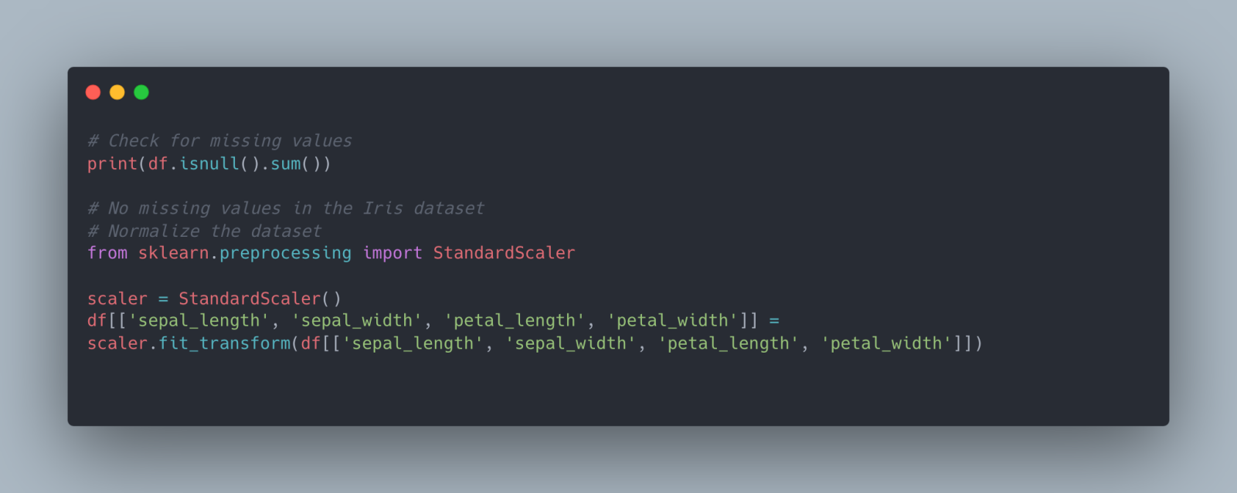

## Step 3: Exploratory Data Analysis (EDA)

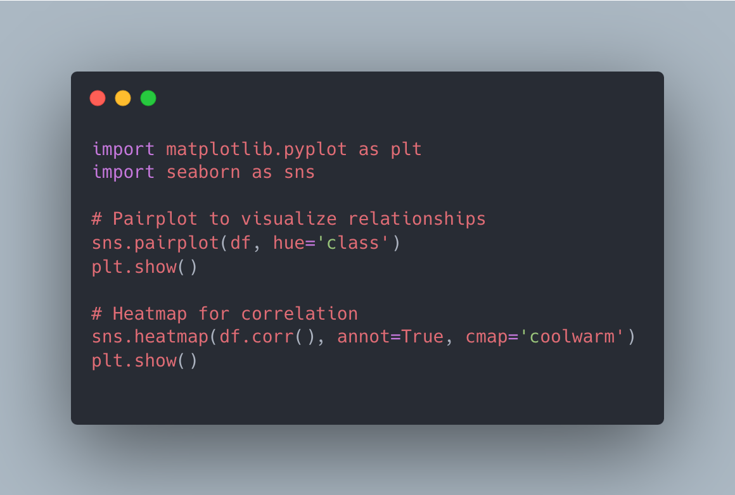

## 

## Step 4: Insight Generation

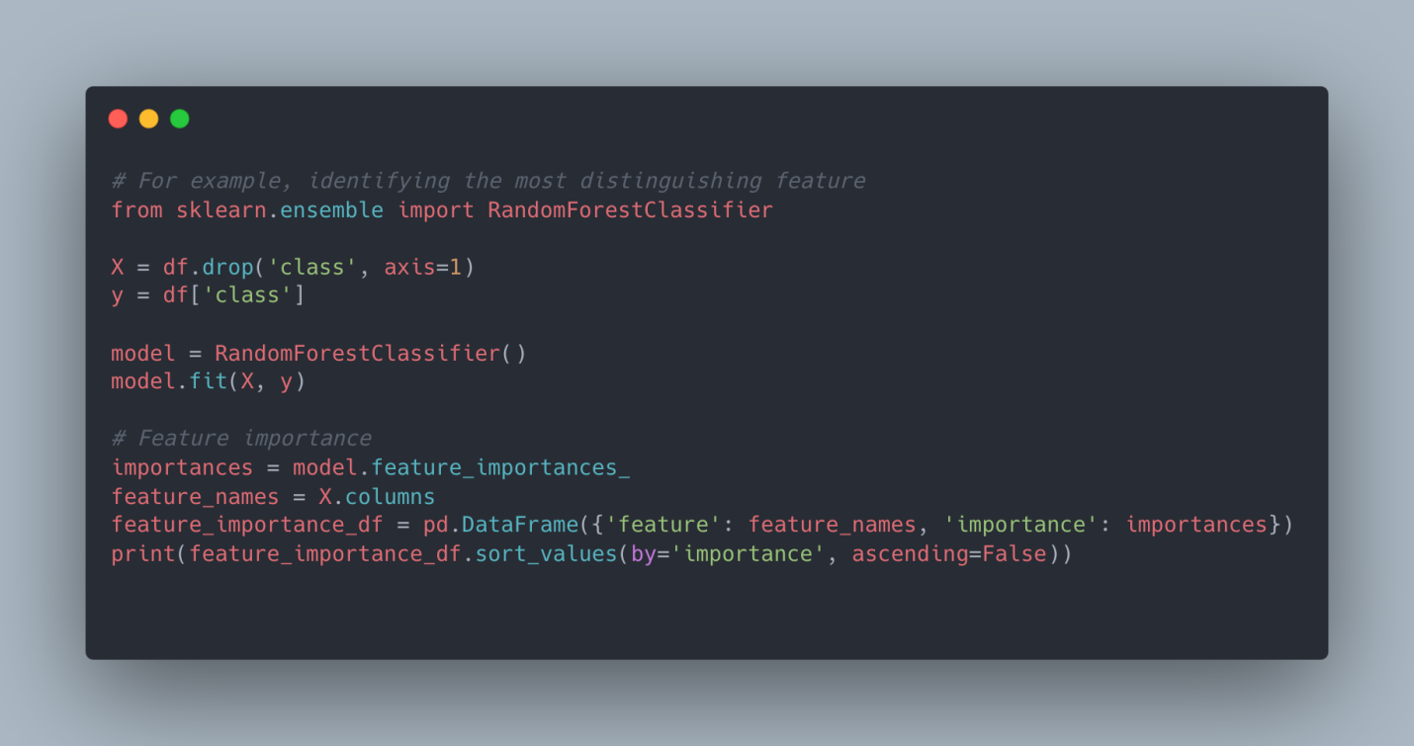

## Step 5: Implementing the Solution in a Scalable Manner

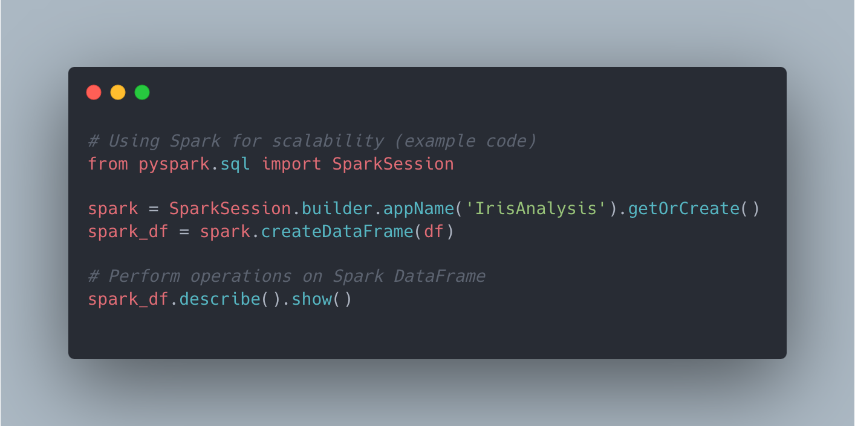

## Step 6: Creating a User-friendly Interface

